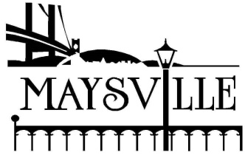
City of Maysville
Utility Department
Billing Adjustment Policy

The purpose of this procedure is to establish agency policy regarding adjustments to customers’ monthly billing.

Pool Adjustments
• Each customer having a swimming pool may have a one-time per year adjustment (on sewer only) for filling the pool.
•The customer should contact the City of Maysville Utility office when the bill covering the filling of the pool is received.
•For existing customers, the high usage must be in excess of 1.5 times the average usage of the customer before the sewer usage will be considered for adjustment.
•For new customers, the high usage must be in excess of 1.5 times the system average usage of 3,000 gallons per month before the sewer usage will be considered for adjustment.
•At the discretion of the Customer Service Department; a City of Maysville service worker may be required to verify the existence of the pool before an adjustment can be given.

Water Leak Adjustments
•Each customer system-wide can be given an adjustment for a verified service-line break when accompanied by a licensed plumber’s statement or other appropriate documentation.
•Each customer is limited to one adjustment per year for each customer service.
•For existing customers, the high usage must be in excess of 1.5 times the average usage of the customer before the leak will be considered for adjustment.
•For new customers, the high usage must be in excess of 1.5 times the system average usage of 3,000 gallons per month before the leak will be considered for adjustment.
•The adjustment may be spread over two months if the leak occurred during two consecutive bill cycles.

Water Leaks Not Eligible for Adjustment
•Repetitive leaks that are a consequence of deteriorating lines and/or other faulty equipment that have not been repaired to City of Maysville specifications are not eligible for further adjustments.
• Irrigations systems, gardening/lawn maintenance and pressure washing will not be considered.
•More than one occurrence per any 12-month period.
•Homes under Construction/Major Renovation

Effective 4/1/18

